Quantum 1/f noise theory and experiment in QWIPs
Amanda M. Truong and Peter H. Handel
Department of Physics & Astronomy and Center for Nanoscience, Univ. of Missouri,St. Louis, MO 63121, USA
Southern Illinois University, Edwardsville, IL 62026, USA, atruong@siue.edu
Abstract
The dark current of Quantum Well Inter-subband Photodetectors is known to be affected by quantum 1/f noise. This limits the detectivity. This paper compares various experimental 1/f noise measurements in QWIPs with the prediction of the conventional quantum 1/f noise expression¹⁻² for GaN/AlGaN QWIPs. The elementary process causing the dark current is the transfer of an electron out of one well. This happens under the influence of the applied electric field, and has in general both thermally activated and tunneling components.The larger the applied electric field, the larger is the squared velocity change of the carriers, and the larger is the obtained conventional quantum 1/f effect. The detectivity of the devices is calculated on this basis. The results are compared with measurements of 1/f noise in QWIPs by C. Jelen³, and 3 others, and the agreement is good.
I. Introduction
Quantum well intersubband photodetectors (QWIPs) yield a dark current that is always present, even without illumination and background radiation. Fluctuations of this dark current will compete with the signal to be detected and limit the detectivity. A first calculation of fundamental 1/f noise in the QWIPS dark current, based on the universal quantum 1/f formulas, is presented and compared with experimental data on GaInAs/InP QWIPs. We will investigate the noise associated with this current. The noise is described by the conventional quantum 1/f effect [4], [6], which describes the fundamental fluctuations in the physical cross sections and process rates that generate the dark current. The calculation of the 1/f noise is then compared to experimental data from Jutao Jiang (and Manijeh Razeghi) [7].
II. Theory
Applying an electric field to the quantum well accelerates the electrons, and the resulting drift velocity gives rise to the dark current. Conservation of energy gives an expression for this velocity
(1)
According to Eq. (2.1), the spectral density of these current fluctuations is given by
(2)
Substituting the velocity change from Eq. (3.1), we obtain
(3)
Next, recalling the relation between the dark particle-current j_{dark} and the number of carriers
(4)
Classically, an electron accelerated between two points has a final velocity of
(5)
The average velocity of the carriers is
(6)
To simplify, we let L = L_{b} + L_{w} represent the lattice constant of the quantum well and use a = eE/m for the acceleration .The dark current is then
(7)
Finally, with this relation between the number of carriers and the dark current, the spectral density can be simplified
(8)
To quantify the dark current fluctuations, we now apply the data and parameters of GaInAs/InP QWIPs
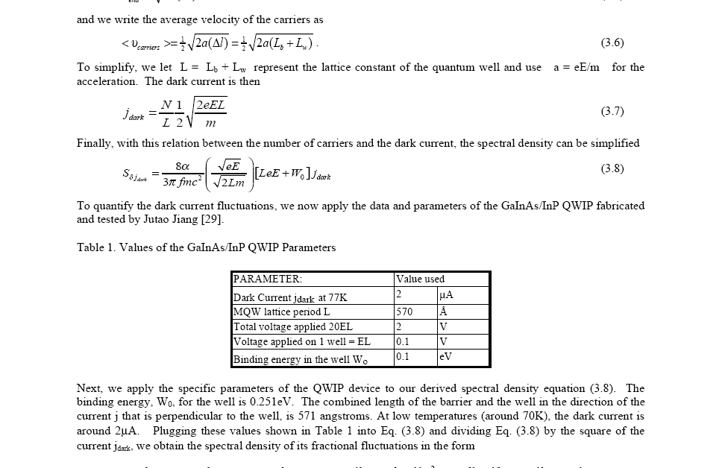
Table 1. Values of the GaInAs/InP QWIP Parameters

Next, to apply the specific parameters of the QWIP device to our derived spectral density equation (8), using a binding energy, W₀, for the well is 0.251eV.
At low temperatures (around 70K), the dark current is around 2μA.Dividing Eq. (8) by the square of the current j_{dark}, we obtain the spectral density of its fractional fluctuations in the form, with the effective mass of the electrons in the InP barrier m=0.077m_{o}
S_{dj/j}(f)=(j_{dark})⁻²S_{dj}=(2.25.10⁻⁹/f)(1.66.10¹²)(8.10⁻¹⁴)48 =1.44.10⁻⁸/f (10)
Amplifying this with the square of j_{dark} =1.25.10¹³/s we obtain the spectral density of dark current fluctuations
S_{dj}(f) =(2.25.10⁻⁹/f)(1.66.10¹²)(1.25.10¹³/s²)=(2.26.10¹⁸/s²)/f (11)
Amplifying this with the square of j_{dark} =1.25.10¹³/s we obtain the spectral density of dark current fluctuations
S_{dj}(f) =(2.25.10⁻⁹/f)(1.66.10¹²)(1.25.10¹³/s²)=(2.26.10¹⁸/s²)/f (12)
The corresponding power spectral density S_{dI}(f) of electrical current fluctuations dI, rms noise current I_{n} and detectivity D* are
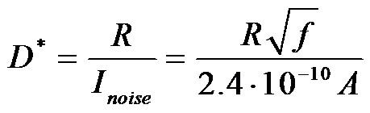
S_{dI}(f) =(1.6.10⁻¹⁹C)²(4.7.10¹⁶/s²)/f = 5.73.10⁻²⁰A²/f
And I_{n}=2.4.10⁻¹⁰ A/f^{1/2}; (13)
III. Comparison with the experiment
Experimental values for the current noise (I_{noise} ) is obtained by means of the detectivity and responsivity data reported by Jutao Jiang. The NEP=P_{equiv} is the optical power producing a signal equal with the rms noise current. The detectivity (D*) is proportional with the inverse of the noise equivalent optical power NEP=P_{equiv},
(14)
Responsivity (R) is defined as the current generated per optical power unit
(15)
This implies that the current noise can be written
or, equivalently, (16)
The data gives the following relations for detectivity and responsivity, both as functions of the bias voltage
(17)
(18)
These expressions can easily be compared with Eq. (12):
(19)
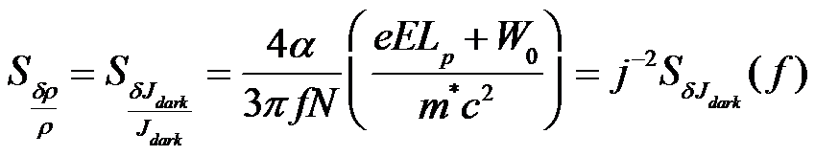
For V=2 volts this experimental result is within one order of magnitude and just slightly larger than our theoretical result of 2.4.10⁻¹⁰ A/f^{1/2} obtained in Eq. (13) above from first principles, without any adjustable parameters. In the Q1/f theory result eq.(8) above, the last 3 factors in the spectral density of current fluctuations are proportional to V^{1/2}, V, and V respectively, resulting in a total proportionality to V^{2.5} for V not too small, in nice agreement with the experiment. In general, the collisions will also be important.To investigate the collision-dominated case, we will consider the drift velocity of the charge carriers to be ν_{d} = μE, where μ is the mobility of the charge carrier. The spectral density is given by
(20)
where total dark current is J_{dark} = n_{o}Aν_{d} = n_{o}A μE. The number of charge carriers N can be written as n_{o}AL where n_{o} is the doping level of the well. L is the total length of the device and L_{p} is the length of the periodicity, or the length of the well and barrier. The effective mass, m*, is related to the mass of the free particle by m*= 0.077m₀.Thus the spectral density is the
(21)
This yields results similar to Eq. (13)
Quantum well devices designed to detect longer wavelengths, e.g. THz, are especially susceptible to increased dark current due to both thermionic emission and thermally assisted tunneling events. In general, the total number of particles defining the dark current consists of the number of carriers that escape out of the quantum wells and the number of these ejected charge carriers, which actually reach the collector of the device. The number of carriers defining the dark current depends on several factors, including donor concentration ρ_{dope}, applied bias U, and the amount of energy W_{o} required for the carrier to escape the well. Considering these factors, based on the empirical form of the observed dark current, we formulate an expression for the total number of charged carriers N that define the scattered current as:
(22)
Where V is the volume of the device, e is the elementary charge, U is the applied bias, and W₀ is the energy required for the donor to escape the well. The above expression gives an approximation for the total number of carriers composing the dark current of the QWIP. To apply the conventional quantum 1/f effect, we must formulate an expression for the momentum change of the carriers. In order to escape the quantum well, the energy required is W₀ , the activation energy, and the energy from the applied voltage U. Together they produce momentum changes, evident when the carriers pass over the next well. Eq. (2) yields the final result, shown in Figs. 1 , 2 below in comparison with experiment
(23)
N is the number of particles used to define the current I_{d} described above, c the speed of light in a vacuum, m* is the effective mass of the carriers.
TABLE 2: Quantum well structure parameters
PARAMETER | Jiang’s Ga_{0.47} In_{0.53} As /InP | In_{0.53}Ga_{0.47}As/InP parameters of Jelen’s sample ‘A’ | In_{0.52}Ga_{0.38}Al_{0.1}As /InP parameters of Jelen’s sample ‘B’ | GaAs/Al_{0.263}Ga_{0.737}As parameters Thibaudeau’s sample ‘A’
MQW periods | 20 | 20 | 20 | 40
Quantum well thickness | 57 Ǻ (Ga_{0.47} In_{0.53} As) | 56 Ǻ( In_{0.53}Ga_{0.47}As) | 59 Ǻ( In_{0.52}Ga_{0.38}Al_{0.1}As) | 52 Ǻ(GaAs)
Barrier thickness | 514 Ǻ(InP) | 400 Ǻ(InP) | 400 Ǻ(InP) | 342 Ǻ (Al_{0.263}Ga_{0.737}As)
Well doping level | 5 x 10¹⁷ cm⁻³ | 8 x 10¹⁷ cm⁻³ | 8 x 10¹⁷ cm⁻³ | 4.7 x 10¹⁷ cm⁻³
Effective electron mass | 0.077 m_{o}(InP) | 0.077 m_{o}(InP) | 0.077 m_{o} (InP) | 0.089 m_{o} (Al_{0.263}Ga_{0.737}As)
Area of QWIP mesa | 400 x 400 μm | 400 x 400 μm | 400 x 400 μm | 0.227 eV
Conduction band offset | 0.251 eV | 0.229 eV | 0.146 eV | 40
IV. Conclusions
From Eqs. (19), (13), and (8) we see that the quantum 1/f formulas correctly describe the 1/f noise in the dark current of QWIPs, both in magnitude and in its dependence on bias. The photo-generation process does not have quantum 1/f noise. New analytical formulas allow for the first time optimization of the QWIPs with respect to parameters such as choice of the semiconductors used, i.e., the effective mass of the carriers, band and subband parameters, well geometry, etc. Quantum well intersubband photodetectors (QWIPs) can be extended in principle from infrared into the THz region.
References
[1] P.H. Handel: "1/f Noise - an 'Infrared' Phenomenon", Phys. Rev. Letters 34, 1492-1495 (1975).
[2] Handel, P.H., “Nature of 1/f Phase Noise”, Phys.Rev.Lett., 34, 1495-1497 (1975).
[4] Handel, P.H., “Quantum Theory of 1/f Noise”, Physics Letters, 53 (A), 438 (1975).
[5] Handel, P.H., "Quantum Approach to 1/f Noise", Phys Rev A, 22, 745 (1980).
[6] P.H. Handel and A.G. Tournier,“Nanoscale Engineering for Reducing Phase Noise in Electronic Devices,” Proc. IEEE 93, 1784-1814 (2005).
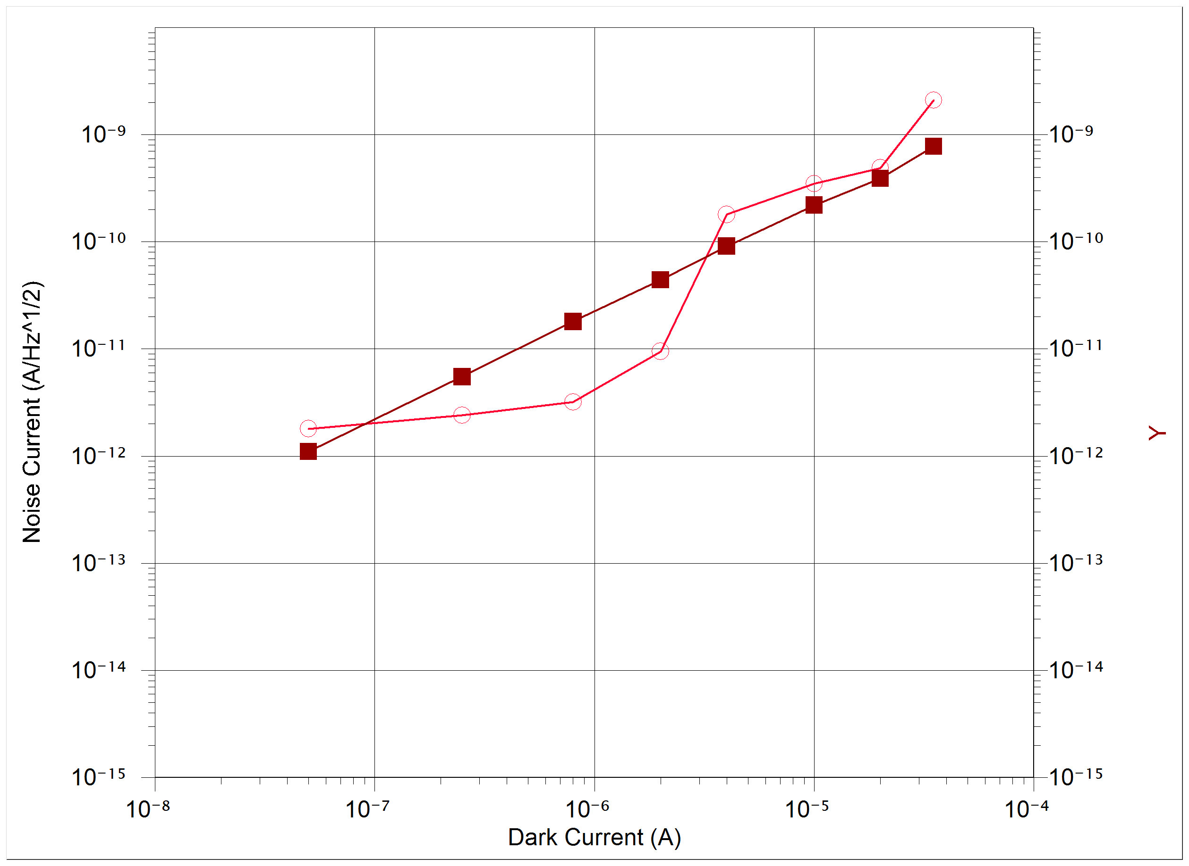
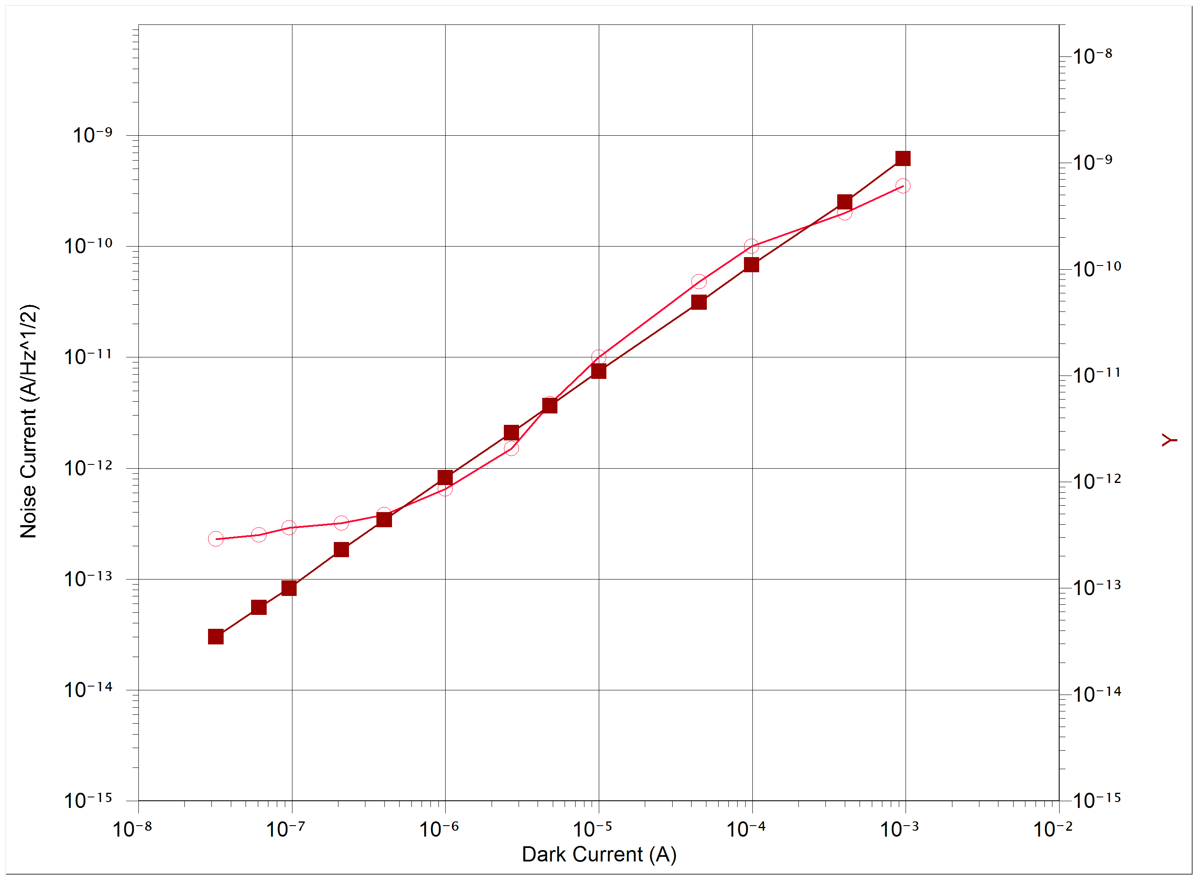
[7] Jelen, C., Slivken, S., Guzman, V., Razeghi, M., and Brown, G. J., “ InGaAlAs–InP Quantum-Well Infrared Photodetectors for 8–20μm Wavelengths”, IEEE J. of Quantum Electronics, 34, 1873-1876 (1998).

Fig.1: Jelen's Sample "A" Curve=Experim. val. Fig. 2: Jelen's Sample "B" Curve=Experim.

